**PROJECT REPORT**

**For**

**School Management Information System**

**By**

Ernest Lasten (Bed-com-05-17) and Chidziwisano Jambo (Bed-com-17-17)

**Document Version: 1.0**

**Date: 5/04/2022**

# TABLE OF CONTENTS

TABLE OF CONTENTS...............................................................................................................1

DOCUMENT INFORMATION....................................................................................................1

LIST OF ACRONYMS..................................................................................................................2

LIST OF TABLES.........................................................................................................................2

LIST OF FIGURES.......................................................................................................................3

1 INTRODUCTION.................................................................................................................4

2 PROJECT DESCRIPTION....................................................................................................5

2.1 PROBLEM STATEMENT.............................................................................................5

2.2 SIMILAR PRODUCTS..................................................................................................6

2.3 UNIQUE VALUE PROPOSITION THET YOUR PRODUCT PROVIDES................7

3 KEY REQUIREMENTS FOR THE PRODUCT...................................................................8

3.1 System description .............................................................................................................8

3.2 User description ..................................................................................................................8

3.3 Non-functional requirements .............................................................................................10

3.4 User friendly ......................................................................................................................12

4 TECHNICAL DESCRPTION OF THE PRODUCT............................................................12

4.1 Overal Architecture ...........................................................................................................13

4.2 Component Diagram .........................................................................................................14

4.3 Database Architecture ........................................................................................................15

4.4 Deployment Architecture ...................................................................................................18

5 PROGRESS SCHEDULE....................................................................................................19

6. Git Repository and API-docs Links........................................................................................19

7 PROSPECTS FOR CONTINUED DEVELOPMENT AND COMMERCIALIZATION...22

8 ROLES PLAYED BY EACH MEMBER OF THE PROJECT TEAM...............................23

9 CHALLENGES FACED & MITIGATION..........................................................................24

10 LESSONS LEARNED..........................................................................................................25

11 CONCLUSION.................................................................................................................26

# LIST OF ACRONYMS

|  |  |
| --- | --- |
| SMIS | School Management Information System |
| DB | Database |
| HTML | Hyper-Text Markup Language |
| CSS | Cascading Style Sheet |
| SQL | Structured Query Language |
|  |  |

# LIST OF TABLES

Table 1 : List of acronomy …………………………………………………………………… 2

Table 2 : work plan …………….……………………………………………………………..19

# LIST OF FIGURES

Figure 1: Login window ………………………………………………………………………11

Figure 2: User interface ….………………………………..……………………………………12

Figure 3: Overall architecture …………………………………………………………………..13

Figure 4: Component Diagram ………………………………………………………………….14

Figure 5: Database architecture …………………………………………………………………15

Figure 6: Deployment diagram ……………………………………………………………….…18

1. **INTRODUCTION**

School Management Information System (SMIS) is web-based application software designed to introduce a conducive and structured information exchange environment for integrating students, parents, teachers and the administration of a primary or secondary school. SMIS will be used by the school administration to keep teachers’ records and students’ academic and personal records. It will be a communication tool for teachers and students’ parents or guardians on students’ academic performance through SMS and comment section.

1. **PROJECT DESCRIPTION**

Student Management Information System software is a web-based system particularly for secondary and primary schools (but colleges can use as well) that will collect data from school staff members, teachers, students and their parents and manage it. School Management Information System will be configurable and can be configured to meet most individual school's needs. It is a multi-user system and can be used by hundreds of users at same time, anywhere, internet connection is all what is required.

School Management System could make school staff's’, teachers’, students’ and students parents’ life easier than ever. Using the School Management Information System, finding student information is just at a click of a mouse, no more time to search in the paper archive, no more costs for phone calls, post office and transportation for sending and posting students’ results. At the end of the term or semester, students’ exams results will be just viewed or printed out in PDF format. As a way of informing parents, SMS messaging will be used to notify them that exams results are out, and if the student is absent, a text message will be sent to parents to let them know. There will be very good communication and coordination between teachers and parents since they will be able to communicate through posting notifications and writing comments using this web application.

## PROBLEM STATEMENT

Even at this computer age, there still exist some institutions that rely on a manual filing system. Using papers to store data, and managing them is very slow, tiresome and costly process. In this technological era many schools are opting for school management information system where computers are used to manage school records, communications and other transactions. This makes the work much easier, fast and efficient as well as effective. On the other hand, the system is simple, easy to understand and use and, going paperless would reduce the cost of maintaining photocopiers and printers; the cost of ink and toner consumables and spares would definitely feature less in the ICT budget. On top of this, schools will be taking the lead in contributing to an eco-friendly means of communication – helping to reduce waste and save trees.

“The Student Management Information System works across the entire student life cycle. Keeping control of student information and managing data has never been easy!” Symon c. Lubanga.

We are to create a system particularly for secondary and primary schools (but colleges can use as well) that will collect data from school staff members, teachers, students and their parents and manage it. School Management System will be configurable and can be configured to meet most individual school's needs. It is a multi-user system and can be used by hundreds of users at same time, anywhere, internet connection is all what is required.

School Management System could make school staff's’, teachers’, students’ and students parents’ life easier than ever. Using the School Management Information System, finding student information is just at a click of a mouse, no more time to search in the paper archive, no more costs for phone calls, post office and transportation for sending and posting students’ results. At the end of the term or semester, students’ exams results will be just viewed or printed out in PDF format. As a way of informing parents, SMS messaging will be used to notify of exams results and if the student is absent a text message will be sent to them as well to let them know. There will be very good communication and coordination between teachers and parents since they will be able to communicate through posting notifications and writing comments.

* 1. **SIMILAR PRODUCTS**

We also researched about other projects that are related to a School management Information System. This has helped us to see the processes and measures they took in creating working and efficient systems. The review has also helped us appreciate how others implemented the assessments section for example that of Chancellor College and this helped us build a robust application that follows improved and acceptable methods and tools of software development and make necessary modifications to suit the modern needs of users.

Some of the applications that are related to the School management Information System are; Student Information System for Kalinga State University-Rizal Campus, Schoolbic, Classter, OpenEduCat and Chancellor college student portal. Schoolbit has almost similar functionalities to our application while the rest of the apps lack one or two things as compared to our web application. For example, Chanco student portal, classter and OpenEduCat have no parent involvement and no SMS system. While our app will have both of these capabilities plus others that are present in the mentioned apps.

## UNIQUE VALUE PROPOSITION THAT OUR PRODUCT PROVIDES

Most of school management information systems have similar functionalities except for one or two of the reviewed application had functionalities that are not present in others. For instance, only one application had the functionality of SMS messaging while the other had the ability to accommodate parents and allow them to converse with the teachers through commenting section. Our application has the best advantage over most of these applications because it has combined the SMS messaging and parents panel functionalities in additional to the regular functionalities into one application thus making it the most ultimate and unique application.

# KEY REQUIREMENTS FOR THE PRODUCT

This chapter provides full description of the system and its users. Then it depicts the

functional and non-functional requirements that have been collected using several methods from

brainstorming, interview and e-surveys.

* 1. **System description**

School Management Information System is a system serving the student, the teacher and parents. The idea of this system is to enable the student to enter the site and get a midterm marks and final exams given by the school, class time table and also check for any information posted by the school’s administration so as to keep pace with all that is happening at school. And again it operates as a system for teachers to share academic information to students’ parents or guardians using SMS messaging and comments section so that they can have a follow up of the student’s class attendance and behaviour in general.

The system keeps user information such as Students and their parents data (Name - Address - Telephone - Mobile - date of birth), and school and teacher data (school name, school/teacher address, school/teacher’s phone number, number of teachers and students, teacher’s name, date of birth, join date, qualification).

The system can also generate student’s academic performance report and time tables according to the student class and subjects which can both be downloaded in PDF format.

**3.2 User description**

There are four main users for the proposed system; these are Admin, student, teacher and the

parent. Each user can perform several different functions during the use of the system. These

functions were determined according to the design of the proposed system and a user-friendly

functions to make the system more effective and efficient. Figure 4-1 summarizes the functions

performed by each user.

**3.2.1 Admin**

The admin is a super users is responsible for doing the following functions once he/she logs into the system.

* Create new Teacher
* Create new Student
* Create new Parent
* Create new Class
* Create subjects
* Assign subjects to teachers and students
* Create posts and SMS messages
* Modify/Delete subject
* Modify/Delete Teacher/student/parent
* Modify/Delete post

**3.2.2 Teacher**

The Teacher once logged in can;

* Add student exams marks
* Modify/Delete students exams marks
* View class time table
* View own profile
* Print class time table in PDF format
* View number of teachers and students at school by gender
* Create comments through comments section
* View comments
* Delete comments

**3.2.3 Student**

Once logged in they will be able to:

* View own class time table
* View own profile
* View exams results
* Print exams results in PDF format
* Print class time table in PDF format
* View number of teachers and students at school by gender

**3.2.4 Parents**

Once logged in the parent should be able to:

* View student’s class time table
* View own profile
* View student’s exams results
* Print student’s exams results in PDF format
* Print student’s class time table in PDF format
* View number of teachers and students at school by gender
* Generate Time Table for Student and Generate
* Create comments through comments section
* View comments
* Delete comments
  1. **Non-Functional Requirement**

**3.3.1 Security**

The system have accounts for its users and only authorized users can access the system

with username and password and the passwords are encrypted.

**Figure 1: user login interface**

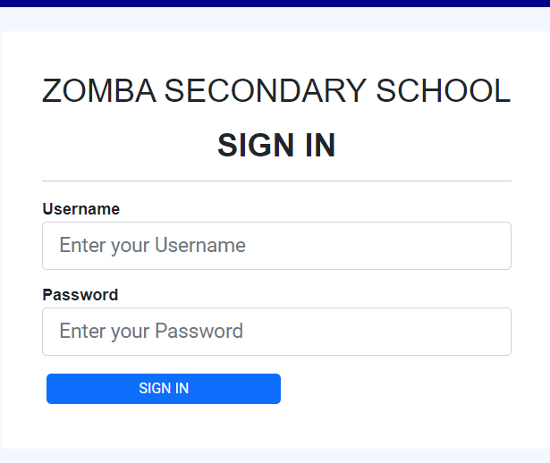

**3.3.2 Performance**

Easy tracking of records and updating can be done easily.

**3.3.3 Availability**

The system is available to users anytime, anywhere, just need a PC with up-to-date web browser and Internet connection. Also the system works in multiple web browsers like (Chrome, Mozilla,

Opera, and Internet Explorer).

**3.3.4 User Friendly**

**Figure 2: user example of user interface**

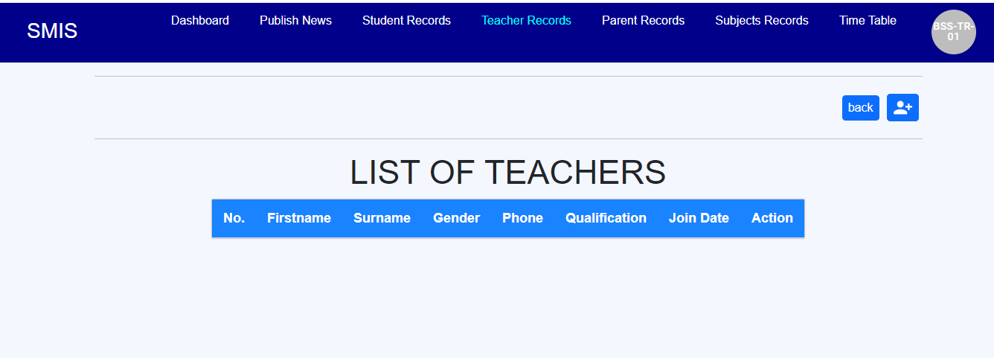

The system has a friendly user interface making it easy to learn and the system is very interactive. The button and other icons and features are visible to users and does not need intensive training for user to start using the software product.

# 4.0 TECHNICAL DESCRPTION OF THE PRODUCT

This part provides technical description of this software product and this includes the following parts; overall architecture, component diagram, Database architecture, technologies used and deployment diagram.

**4.1 Overall architecture**

The Software Architecture describes basic software structure by separating functional areas into layers. It depicts how a typical software system might interact with its users, external systems, data sources, and services.

**Figure 3 shows the overall architecture of this school management information system.**

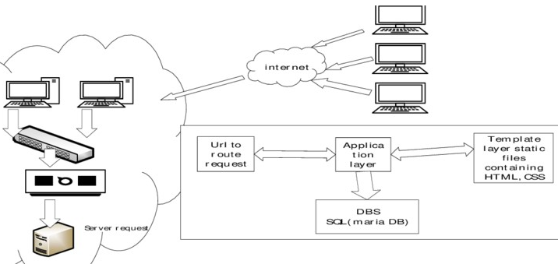

**4.2 Component Diagram**

This part shows how components of this school management Information system are wired together to form larger components or software system

**Figure 4: Shows Component Diagram for this web application.**

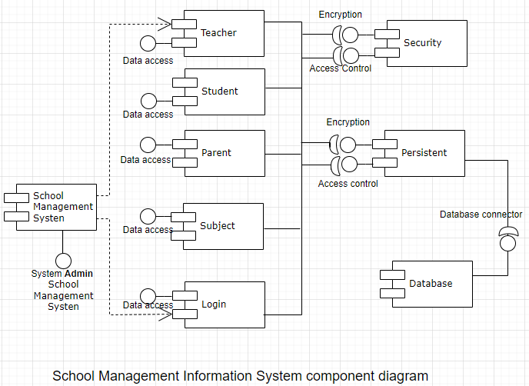

**4.3 Database architecture**

We used MySQL database with MariaBD engine. MySQL runs on all major operating systems like, Linux, Windows, and macOS. Because of its features and its cost-effectiveness, MySQL is used by big enterprises used by high profile web properties including Facebook, Twitter, YouTube, Yahoo! and many more.

**Figure 5, Shows schematic Diagram of the database for this web application.**

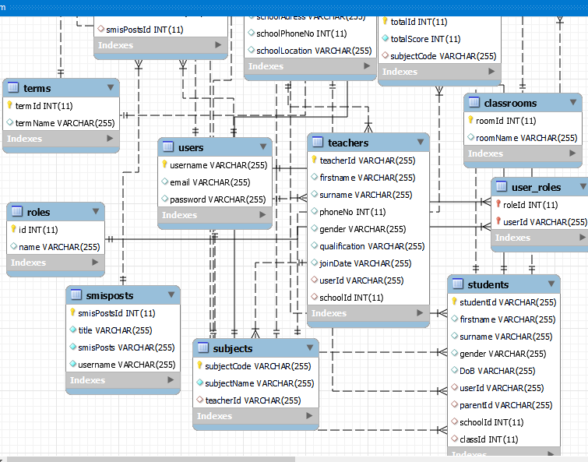

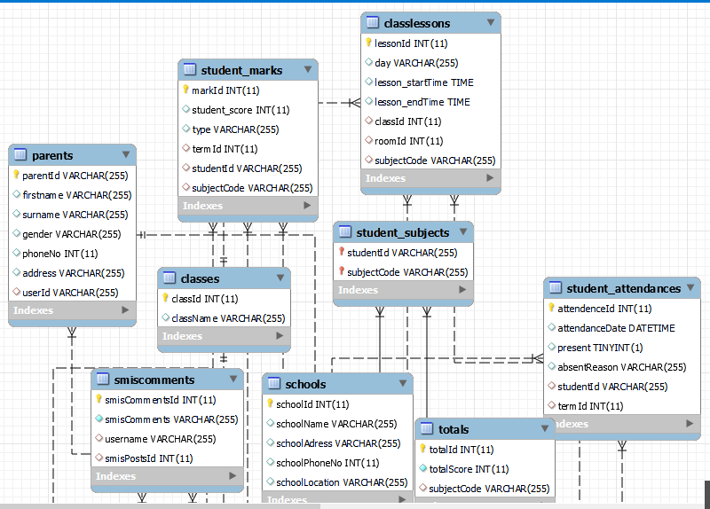

**4.4 Technologies used**

MySQL is one of the most popular databases in the world, if not the most

popular. Per the 2020 Stack Overfl ow survey, MySQL was the most-loved

database, with more than 55 percent of respondents using it. The community

edition is freely available, supported by a large and active community.

MySQL is a feature-packed relational database first released in 1995. MySQL

runs on all major operating systems like, Linux, Windows, and macOS. Because

of its features and its cost-effectiveness, MySQL is used by big enterprises used by high profile web properties including Facebook, Twitter, YouTube, Yahoo! and many more.

**HTML:** is the standard markup language used to create web pages. Web browsers can read

HTML files and render them into visible or audible web pages. HTML elements form the

building blocks of all websites. HTML allows images and objects to be embedded and can be

used to create interactive forms. It provides a means to create structured documents by denoting

structural semantics for text such as headings, paragraphs, lists, links, quotes and other items.

**CSS:** is a Web page derived from multiple sources with a defined order of precedence where the

definitions of any style element conflict. The Cascading Style Sheet, level 1 recommendation

from the World Wide Web Consortium (W3C), which is implemented in the latest versions of the

Netscape and Microsoft Web browsers, specifies the possible style sheets or statements that may

determine how a given element is presented in a Web page. And describes how HTML elements

are to be displayed on screen, paper, or in other media**.**

**Express.js** is a server-side application framework for node js that wraps HTTP requests and responses and makes it easy to map URLs to server-side functions.

**React.Js** is a front-end JavaScript framework for building interactive user interfaces in HTML and communicating with a remote server.

**4.5 Deployment architecture**

Deployment architectureof School Management System shows components, provided and required interfaces, ports, and relationships between the Classes, Registration, Teacher, Student, parent and Subject.

**Figure 6, shows a Deployment Diagram.**

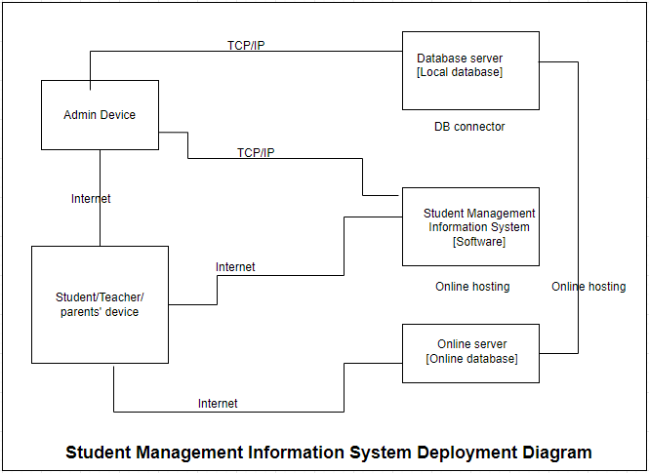

5 Code Documentation (should be system generated and should be provided in a separate document)

1. Link to GIT repository

<https://github.com/JAMBO-CHIDZIWISANO/school-information-management>

**Link to api documentation**

http://localhost:4000/api-docs

1. **PROGRESS SCHEDULE**

We used the following table ( table 2) to schedule our work during the development of this product.

|  |  |  |  |  |  |  |
| --- | --- | --- | --- | --- | --- | --- |
| **Activity ID** | **Activity name** | **Objective** | **Priority** | **Activity date** | **Planned output** | **Person assigned** |
| 1 | Database design and implementation | To produce ERD for SMIS database | High | Week 11  21 - 25 Feb, 2022 | ERD for the application | Ernest Lasten, Jambo Chidziwisano |
| 2 | Interface design | To develop forms for registering teachers, parents and student, subjects, class, marks | High | Week 11  21 - 25 Feb, 2022 | Front-end interfaces registration for teachers, parents and students | Ernest Lasten |
| 3 | Connection between Front and back-end | Write code using NodeJs to connect front end with back end (Routes) | High | Week 11  21 - 25 Feb, 2022 | working part of the product (admin part - registering and storing information in database) | Jambo Chidziwisano |
| 4 | Comment section (both back and front ends) | Write code using node Js and express framework and SQL statements | High | 7 March -11 April | Completed and working comments section | Ernest Lasten |
| 5 | SMS messaging section (both back and front ends) | Write code using node Js and express framework and SQL statements | High | 14 - 18 March | Completed and working SMS messaging section | Jambo Chidziwisano |
| 6 | Posts functionalities both front and back ends | Write code using node Js and express framework and SQL statements | High | 28 March - 4 April | Completed and working Posts section | Ernest Lasten |
| 7 | Authentication of users | Restrain users from accessing other information | High | 28 March - 4 April | System that authenticate and validate users | Jambo Chidziwisano |
| 8 | Validating the forms and adding more forms for editing and managing subjects, grade, teachers, parents, | Display error messages, validate passwords, filter information | High | 11-15 April | Display error and success messages, allow user to confirm delete action and clear forms as well as reloading window when action is successful | Ernest Lasten and Jambo Chidziwisano |
| 9 | Modifications and improvements of the forms and functionalities for teacher panel and marks forms | Get the required user and system requirements | High | 18-22 April | Improved system with few steps to achieve a task | Ernest Lasten, Jambo Chidziwisano |
| 10 | CSS and code Clean ups | Styling the product | High | 25-29 April | Well looking and responsive system, clean code | Ernest Lasten, Jambo Chidziwisano |
| 11 | Full Documentation of the project | Writing full documentation of the product and drawing the figures for the product architectures | High | 2 - 3 May, 2022 | Full documentation of the product in PDF or text format | Ernest Lasten |
| 12 | API-documentation | Write API-documentation | Medium | 2 - 3 May, 2022 | A form for connecting and performing delete/update/create functions using APIs | Jambo Chidziwisano |

# PROSPECTS FOR CONTINUED DEVELOPMENT AND COMMERCIALIZATION

* 1. The app needs to be tested with many users and moderated then make an upgrade and include in Human resource features where teachers can drop complaints or queries. And they can apply leave using the app.
  2. **Commercialization**
  3. We will deploy the app on play store and will use subscriptions a commercialization strategy and we will also use random in-ads to generate more revenue from the product. Each school will have to be paying a subscription fee be it monthly or annually in order to continue using the app and receive service upgrades.

# ROLES PLAYED BY EACH MEMBER OF THE PROJECT TEAM

* The project is divided into two major ends, front and back. Therefore, Ernest Lasten was mainly working on developing the front-end (user Interface).
* Posts section, both back and front ends were done by Ernest Lasten
* Comments section both back and front ends were done by Ernest Lasten
* SMS section was done by Jambo Chidziwisano both fornt and back ends
* User authentication Jambo Chidziwisano.
* Add teacher, students, parents and subject plus the delete functions were done by Ernest Lasten
* The update functions for marks, Teachers and parents were done by Jambo

**NOTE**:

* But there are areas we developed together such as the entire database design was done together. And we also interchanged roles in developing this software for instance, Ernest Lasten developed the entire front end of commenting and post sections as well as its back-end while Jambo developed the entire SMS and feature both on its front and back ends. And for most parts that required technical support we sit down and figure out the solution to the problem together and divide the work accordingly. We also had to sit down and agree on the design of the user interface and discuss the arrangement, coluor and appearance of the buttons and forms as well as the whole user interface.

# CHALLENGES FACED & MITIGATION

1. During the development of the project we face the following chalenges that hindered the smooth development of our software.
2. Network problem. We largely depend on University of Malawi WiFi and sometimes the network could be down for some days as such our work would go slow since some dependencies rely on the network connectivity to function.
3. Unfamiliarity with some technology we used. There were some technologies we used that we were not very familiar with for example, Axios, Express and some react hooks that have been modified and upgraded over the years. So we had to spend some time studying them then get back to using them. This consumed much of our time during the development of the software.
4. Electrical problem. We depended on university lab’s computers to access the internet and develop our software. But many times there were electricity outage and this affected our work as we had no power back up and our laptops have no batteries. So if this happens we could wait until electricity fault is fixed.
5. **What challenges remain unresolved?**We failed to have the a form where very student name has a field to add marks and submit the contents of all the fields at once.

# LESSONS LEARNED

We have learned the following lessons during the development of this product.

* It is very good important to meet and communicate to your supervisor or key stakeholders regularly so that you get feedback, advice on how to move on or go about other things that are crucial for the product under development and clear assumptions and expectations.
* Start with key requirement during software development
* Add error handling early in the program development as this becomes difficult to handle at later stage
* Always plan first and stick to the plan

# CONCLUSION

In recent years, with the pace of technological development, people have become more and more

demanding in terms of quality of life, and the schools managers in recent years look to improve a

performance in their schools to get the highest rate of knowledge and experience in their students. As such using this School Management Information System will give them the flexibility and ability to improve performance in records keeping, fast information processing and retrieval and facilitation of faster communication between teachers and parents. All of this will result in efficiency and effectiveness of the school’s administration.

**Areas of improvement**

Here are some ideas and features that can be considered as a future work for this project.

* Let the students take a testing exams Online. This can be an aptitude test or any exams to improve their learning or to assess them on what they learn.
* Fees payment functionality
* Library Management section
* Online registration. Parents can register for their children or children can register for themselves.
* Teacher leave application

•